# 

The first time you log in to Prax-Manager, the main screen with three different options on the left section appears. The first one is Internship where teachers can introduce information about the practices of the students.

To add a new mobility or practice, the teacher has to click on the button "Add Internship"

located on the top right.

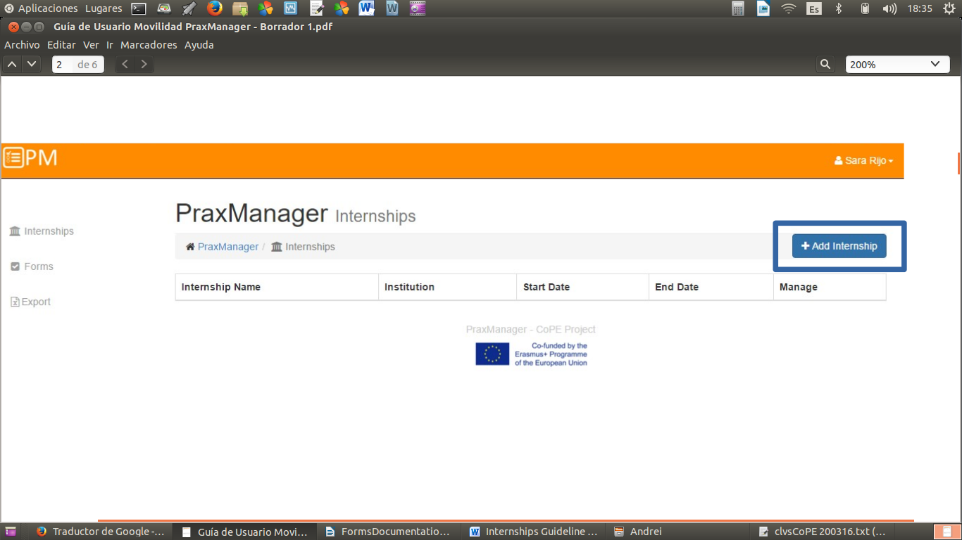

Once he clicks on the add Internships button, a form is open and the following fields will have to be written:

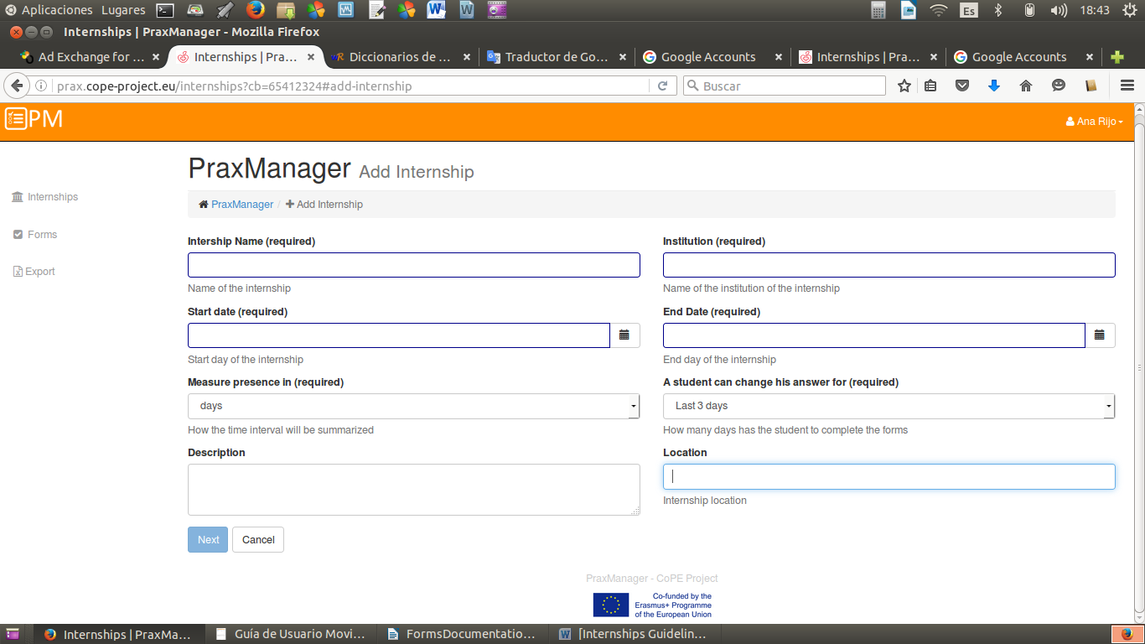

**Internship Name -** The name of this field should describe the practice to be performed by the students.

**Start date –** This field describewhen the students should begin the practice in the company.

**End Date -** This field describewhen the students should finish the practice in the company.

**Measure presence in** - when teacher click on the drop down, two options appear:

* Days - The time interval will be summarized in days.
* Hours and minutes - The time interval will be summarized in hours and minutes.

**Description** - A short description of the main features of the internship

**Institution** - Name of the institution of the internship

**A student can change his answer for** - When teacher click on the drop down, three options appear:

* Last 3 days - the student has 3 days to complete the forms
* Last 7 days - the student has 7 days to complete the forms
* Last 30 days - the student has 30 days to complete the forms

**Location –** The place where the internship is going to be done.

*Warning*: All fields with the “(required)” label need be completed in order to save the form.

The action can be cancelled by clicking “Cancel” button returning to the home screen of Prax-manager section.

If action is not cancelled, when teacher have filled in the entire field in the form, he must click on the button below “Next” to finish completing the mobility information.

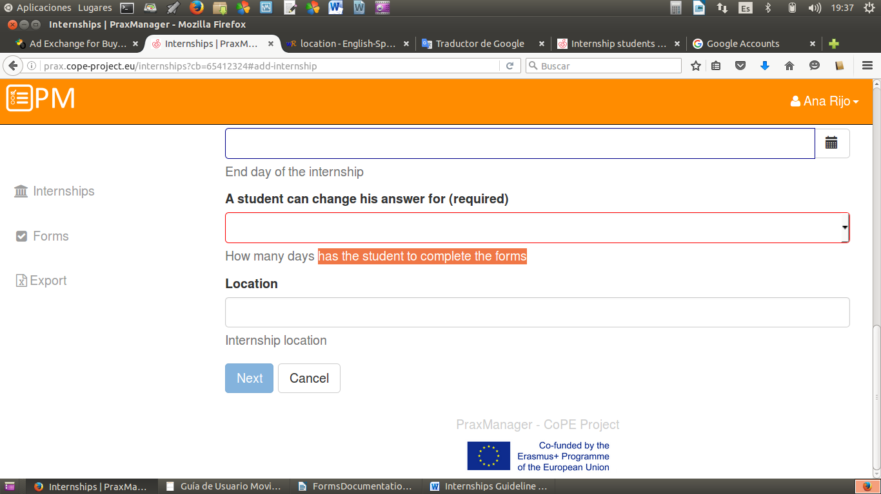

In the following view, appear the various components that could be added to the mobility.

* Add students to internship
* Add Manager to internship
* Add forms to internship

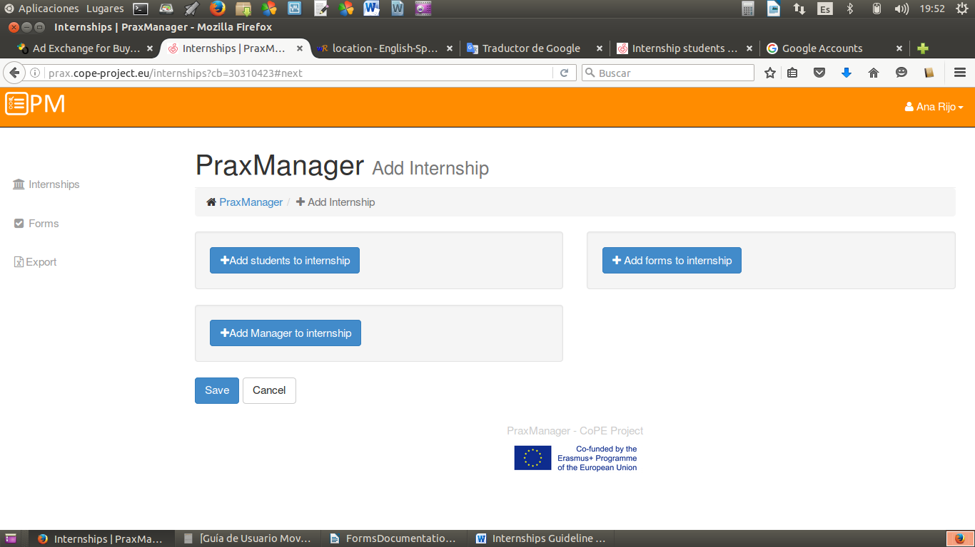

Now we will describe in detail each one of them.

**Add students to internship button** – the teacher can add students to the practice created, individually, by clicking on the drop down

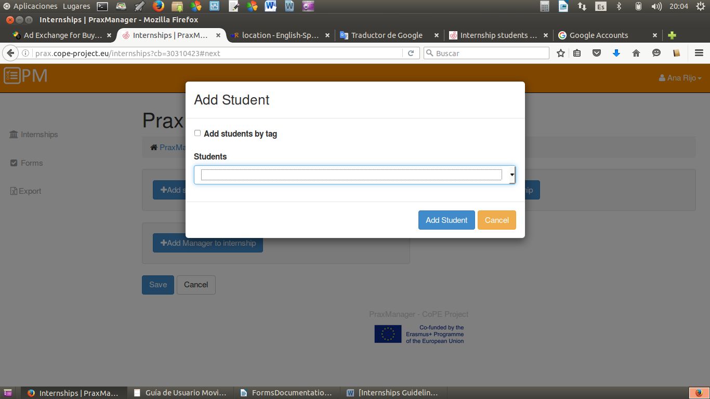

And choosing the students that appear

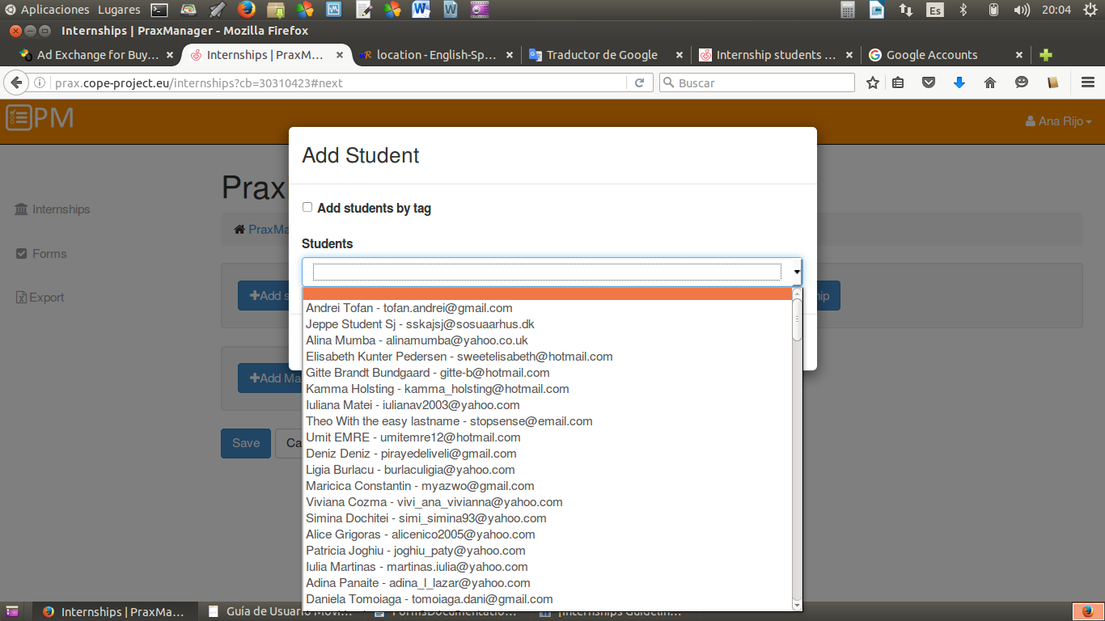

Or collectively, by marking "Add students by tag" where you can select a group of students, previously registered, and grouped by a tag.

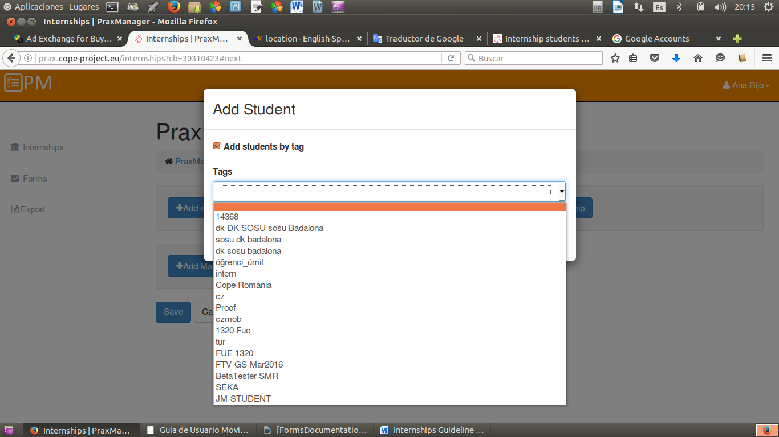

**Add forms to Internship button** –Clicking on the drop down add form, it would be possible to choose between different previously created forms.

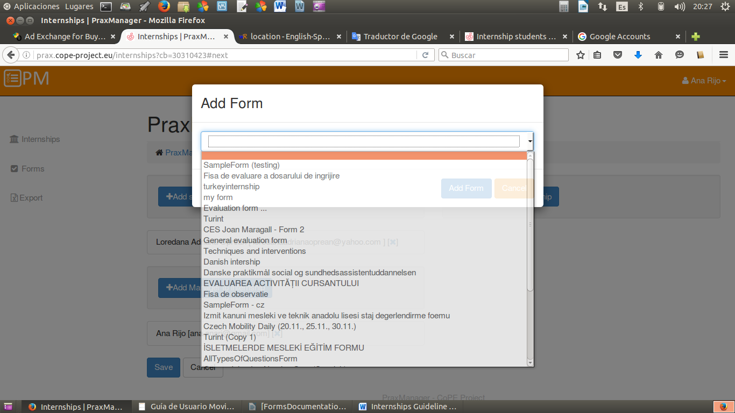

**Add Manager to Internship button** – Here should be chosen the tutor of the students in the internship created.

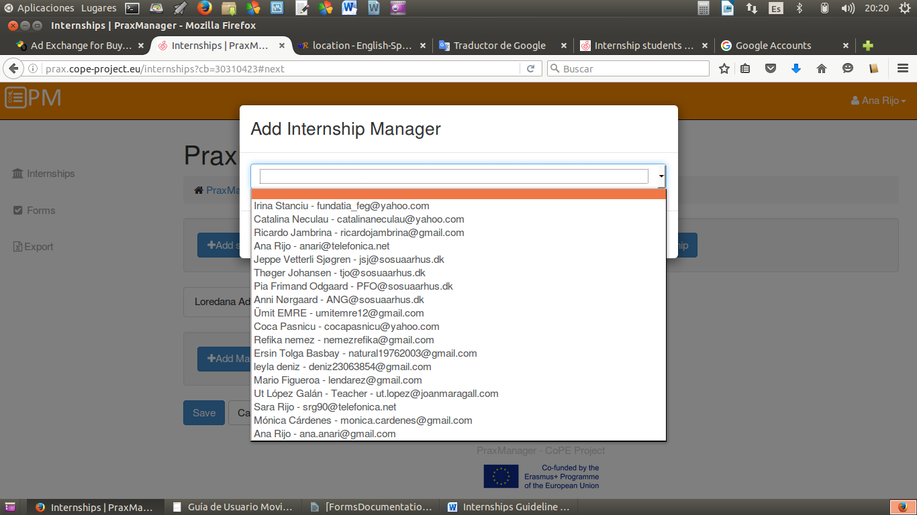

When the three options have been completed, the Internship will be created by clicking in the Save button.

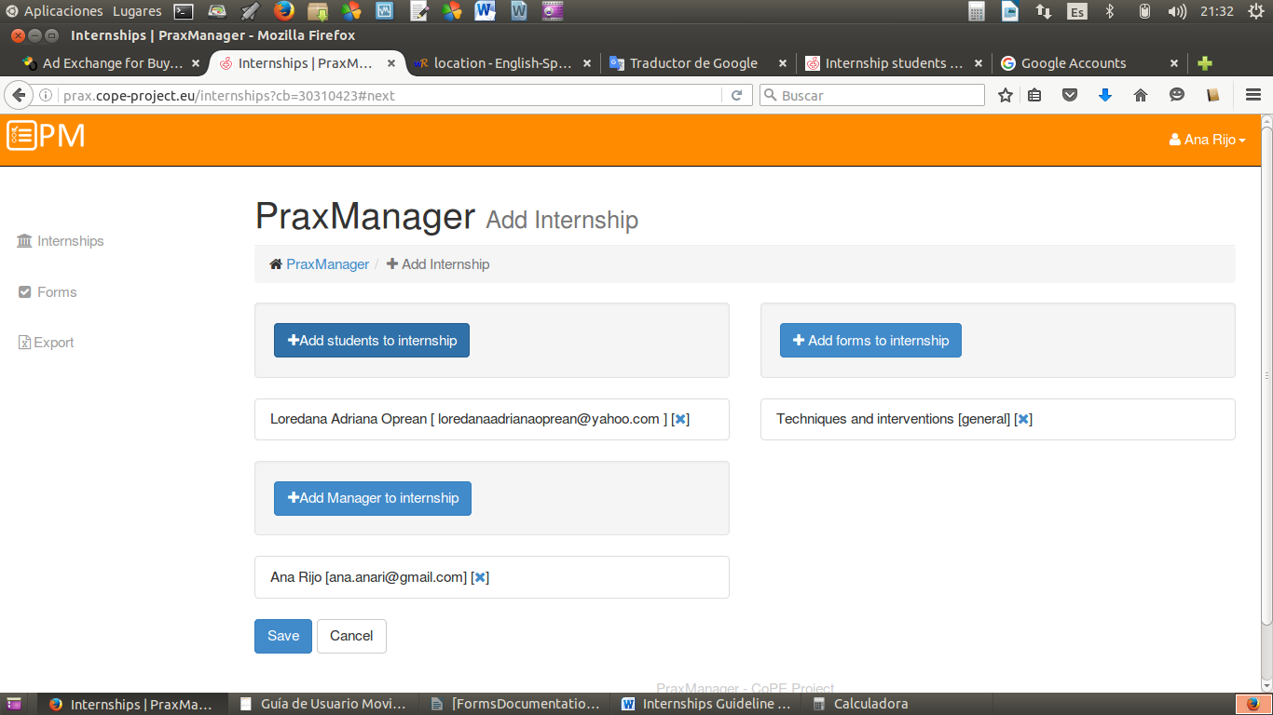

From that time the Internship is saved and the teacher could manage it by clicking on the drop down Manage option, where appear five options to choose:

* Manage Internship
* View as student
* Edit
* Archive
* Delete

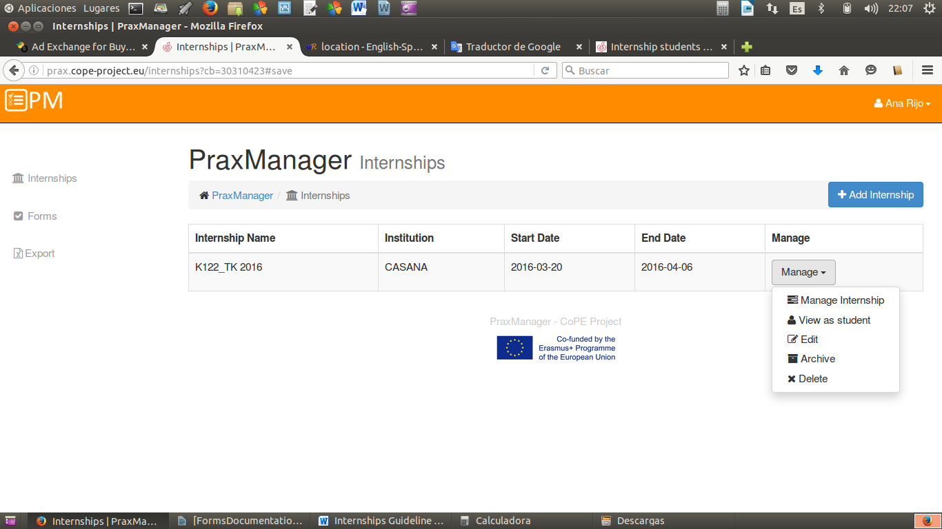

**Manage Internship -** Entering this option it would be possible to have three new possibilities:

* Submitted Form
* Student Presence
* Send Notifications

Submitted Form – Here the forms are sent to the student

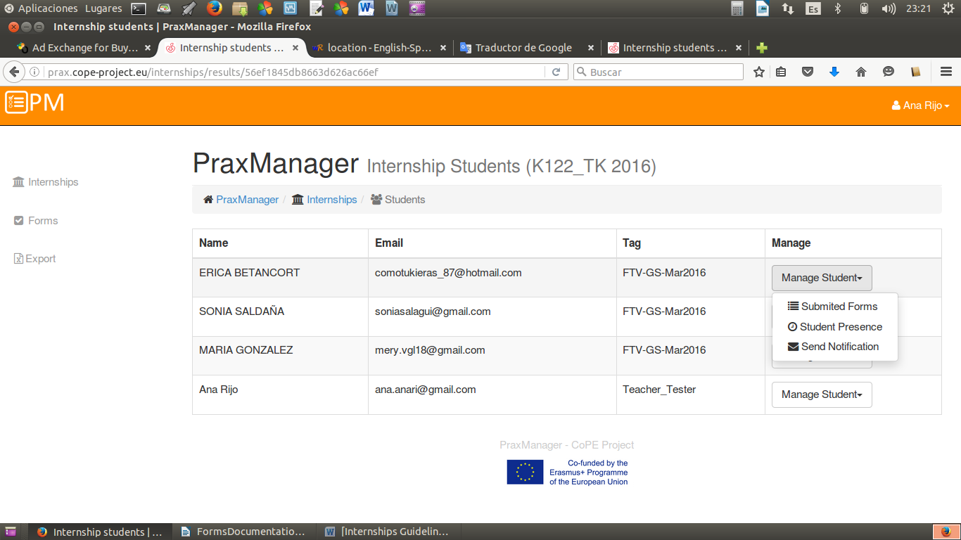

Student Presence - Teacher controls the student attendance to the enterprise

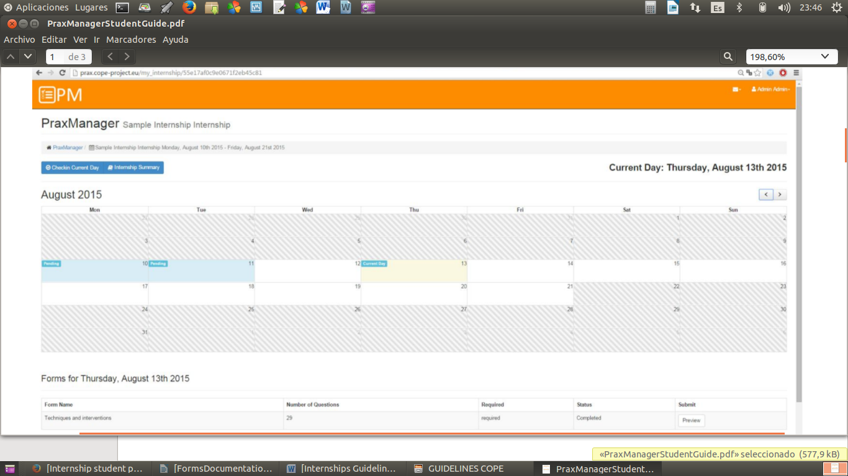

Send Notifications - Choosing this option the teacher can send emails to students.

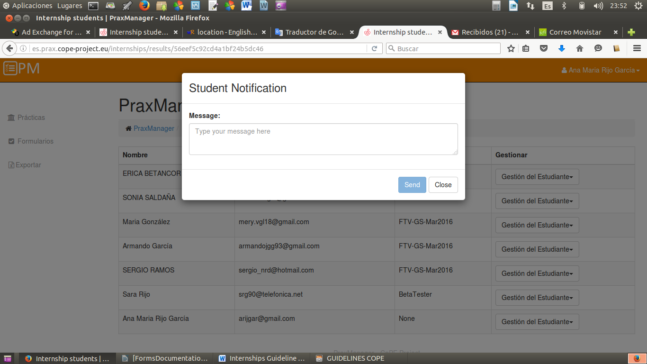

**View as student -** Here teacher will have the same view as the student.

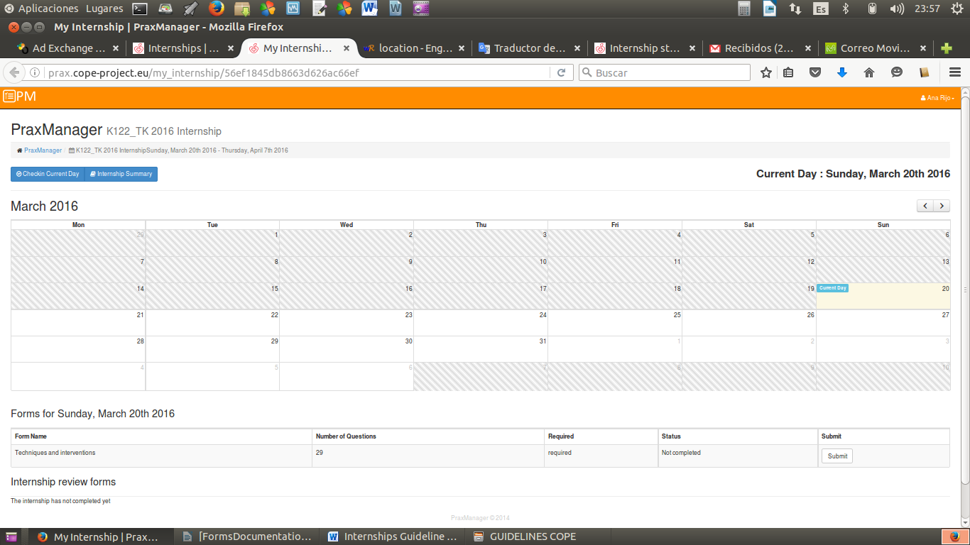

There are two buttons:

* Checking Current Day - It shows the activities that the student has done this day.
* Internship Summary - It shows a summary of all practices that the student has done during the Internship.

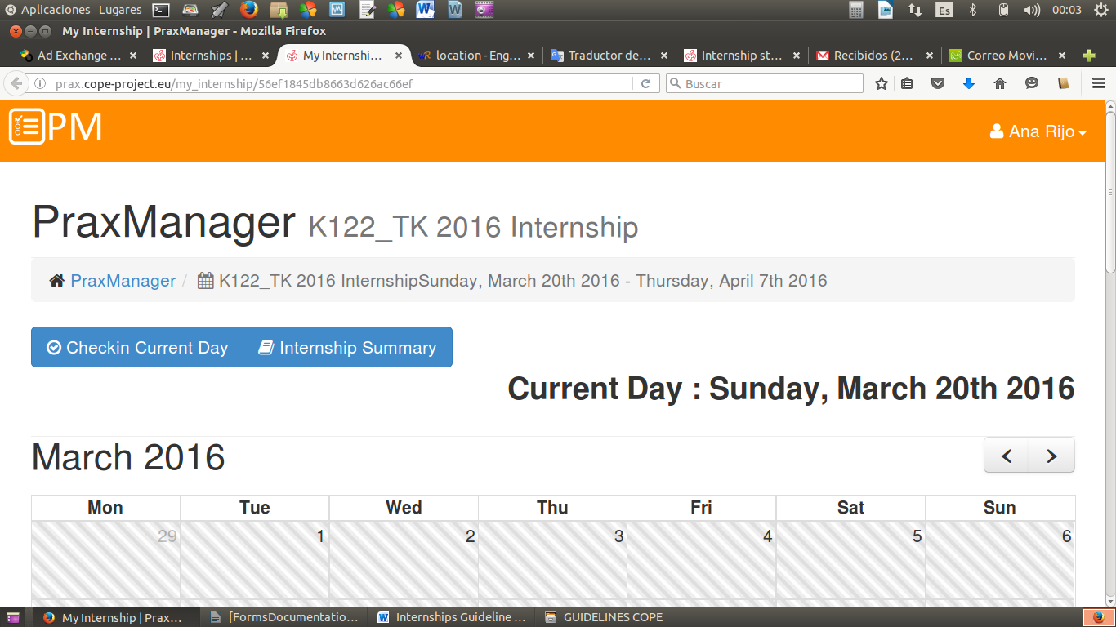



**Edit –** This option is to change any item of previously introduced.

**Archive -** when all the changes have done and the practice is over this option will keep it permanently saved.

**Delete -** Teacher chooses this option to eliminate permanently the Internship.